**Ground Truth Mask Data Generation and Augmentation for Machine Learning Dataset**

**Data Preparation**

We used the VGG Image Annotator to draw contour for **ground truth mask**.

1. Open the [VGG Image Annotator website](https://annotate.officialstatistics.org/)
2. Click on the Add Files button



1. Upload heart images

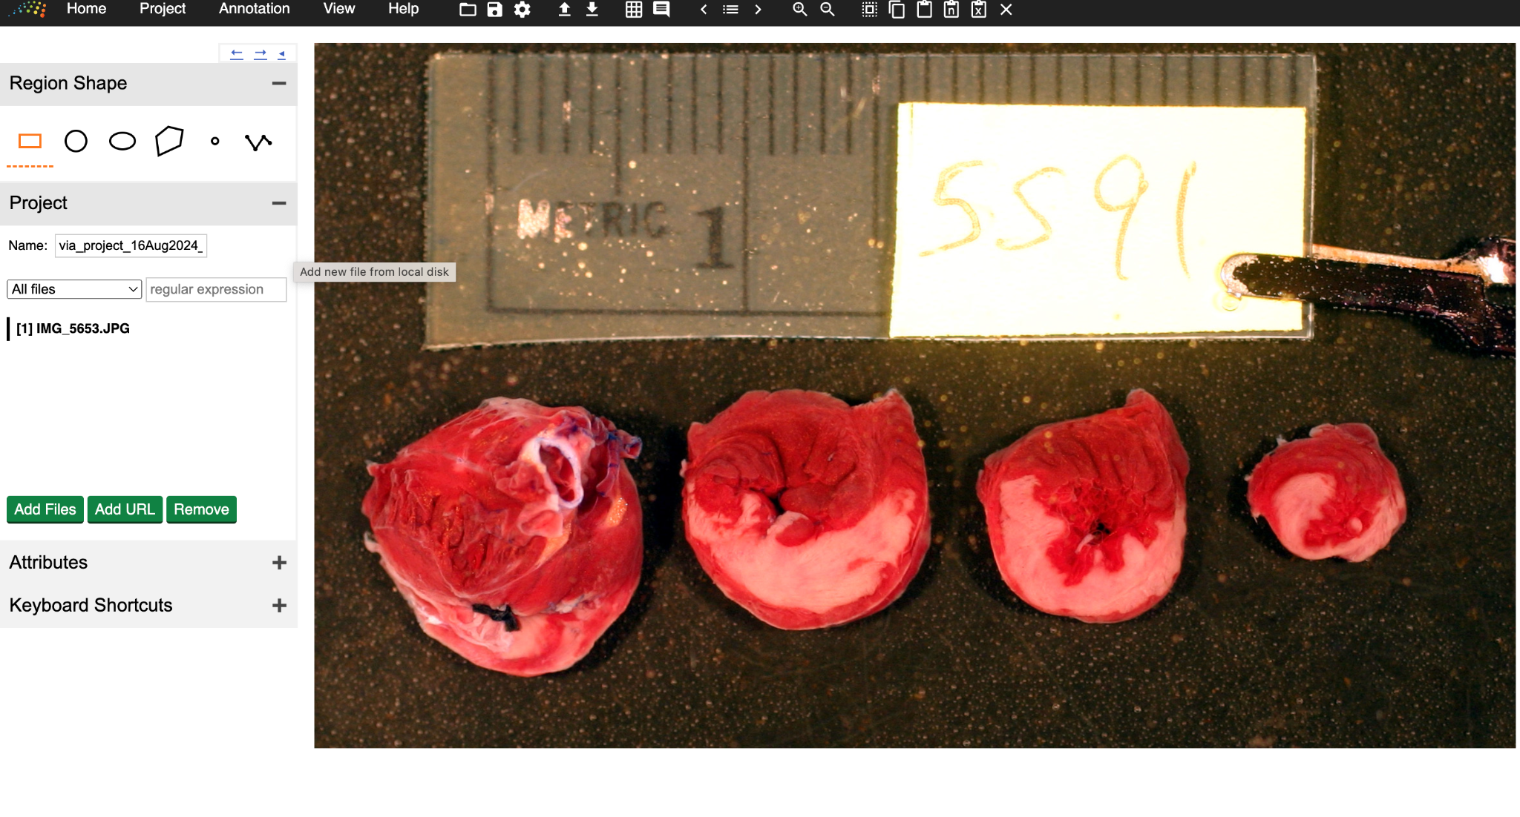

1. Select polygon/polyline region shape



1. After finishing contouring, click on the *Project* tab and click *Save*. The contours will be saved as a json file at your computer Downloads folder.





We will then run the **Data Processing Program** to draw masks and perform data augmentation.

1. Download the Data Processing Program folder, and open it using IDE software such as VScode. After that, run the *app.py* file.





1. Open the webpage with http://127.0.0.1:5000



1. Choose one of the following options based on your needs: draw masks only, perform data augmentation only, or do both simultaneously.



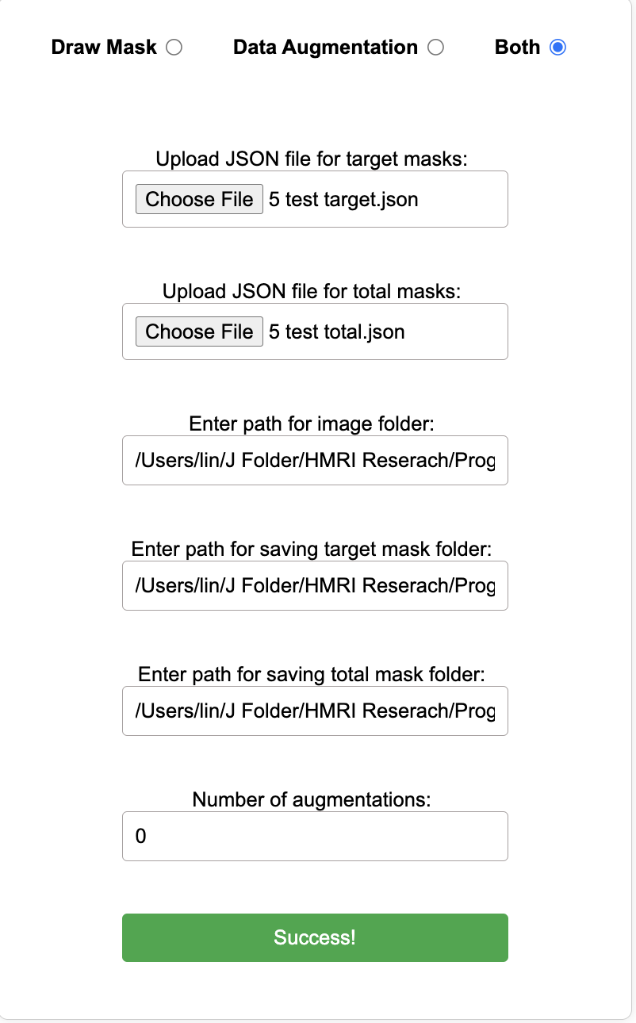

*REMINDER: The image folder should contain the original images that correspond to the contours you’ve created.

1. The masks/augmented data will then be generated in the folder you chose to save.